INSTALLATION ON ICINGA SERVER SIDE
Requirements
Note: Make sure the following development tools and development libraries have been installed

GCC compiler
C/C++ development libraries
GD development libraries

Packages Needed

- Xampp for Linux:

Download Xampp for Linux (version 1.7.3) from http://sourceforge.net/projects/xampp/files/XAMPP%20Linux/1.7.3/xampp-linux-1.7.3.tar.gz/download

- Icinga Core:

Download Icinga core from
http://sourceforge.net/projects/icinga/files/icinga/1.2.1/icinga-1.2.1.tar.gz/download

Installation of Icinga

- Login as root user

- Untar the Xampp package

[root@localhost software]# tar -zxvf xampp-linux-1.7.3.tar.gz
[root@localhost software]# mv lampp/ /opt/

- Untar the Icinga package

[root@localhost software]# tar -zxvf icinga-1.2.1.tar.gz
[root@localhost software]# cd icinga-1.2.1
[root@localhost icinga-1.2.1]# ./configure --prefix=/opt/icinga --with-icinga-user=daemon --with-icinga-group=daemon --with-httpd-conf=/opt/lampp/etc

Note: please make sure you do not get any error while compiling. If you are getting errors make sure the required packages are installed.

[root@localhost icinga-1.2.1]# make all
[root@localhost icinga-1.2.1]# make install
[root@localhost icinga-1.2.1]# make install-config
[root@localhost icinga-1.2.1]# make install-commandmode [root@localhost icinga-1.2.1]# make install-webconf

- Configure Apache with Icinga

[root@localhost icinga-1.2.1]# cd /opt/lampp/etc/
[root@ etc]# vim httpd.conf

- Add the following line to httd.conf

Include etc/icinga.conf

- Set password for login

[root@localhost /]# cd /opt/lampp/bin/
[root@localhost bin]# ./htpasswd –c /opt/icinga/etc/htpasswd.users icingaadmin

New password:
Re-type new password:
Adding password for user icingaadmin

- Start Apache

[root@localhost lampp]# cd /opt/lampp/ [root@localhost lampp]# ./lamp startapache

XAMPP: Starting Apache with SSL (and PHP5)...
XAMPP: Error 1! Couldn't start Apache!
XAMPP: Starting diagnose...
XAMPP: Make the httpd.conf fit your system.
XAMPP: Next try...
XAMPP: Starting Apache with SSL (and PHP5)...

- Check whether Apache is working:

http://localhost

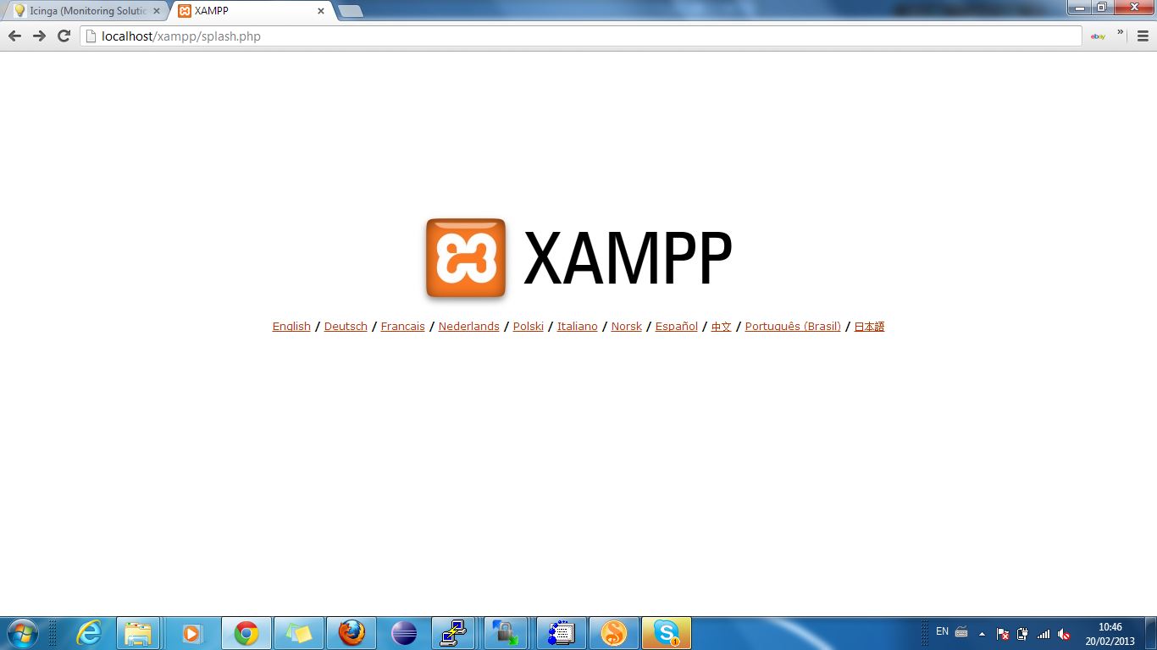

- Check whether Icinga has been compiled properly

[root@localhost lampp]# cd /opt/icinga/

- Check whether all the configuration are set

[root@localhost icinga]# /opt/icinga/bin/icinga –v /opt/icinga/etc/icinga.cfg

Total Warnings: 0
Total Errors: 0

Note: Every time after making any configuration changes, it is advised to perform the above step before restarting icinga.

- Now Start Icinga since we didnt get any errors in above step

[root@localhost icinga]# /opt/icinga/bin/icinga -d /opt/icinga/etc/icinga.cfg
[root@localhost icinga]# ps -ef|grep icinga

daemon 6961 1 0 19:03 ? 00:00:00 /opt/icinga/bin/icinga -d /opt/icinga/etc/icinga.cfg
root 6998 2929 0 19:05 pts/1 00:00:00 grep icinga

[root@localhost /]# chmod 777 /opt/
[root@localhost /]# chmod 777 /opt/icinga/
[root@localhost /]# chmod 777 /opt/icinga/var/
[root@localhost /]# chmod 777 /opt/icinga/var/rw/
[root@localhost /]# chmod 777 /opt/icinga/var/rw/icinga.cmd

- Login to check whether Icinga opens

http://localhost/icinga

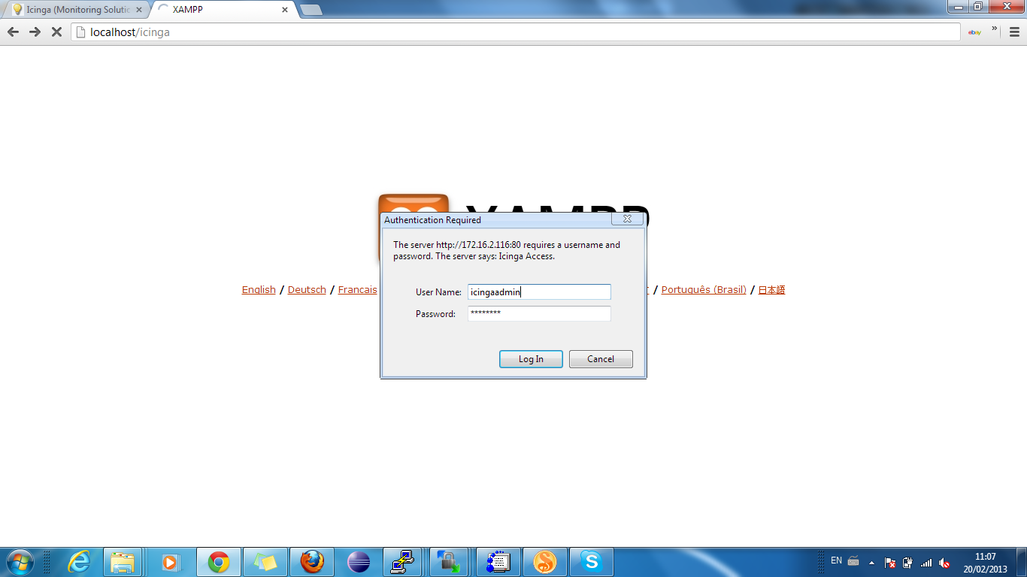

- Download the Nagios plugin and compile the same

http://prdownloads.sourceforge.net/sourceforge/nagiosplug/nagios-plugins-1.4.15.tar.gz

[root@localhost software]# tar -zxvf nagios-plugins-1.4.15.tar.gz
[root@localhost software]# cd nagios-plugins-1.4.15
[root@localhost nagios-plugins-1.4.15]# ./configure --prefix=/opt/icinga/ --with-nagios-user=daemon --with-nagios-group=daemon
[root@localhost nagios-plugins-1.4.15]# make && make install

- Mail alert configuration

[root@localhost /]# cd /opt/icinga/etc/
[root@localhost etc]# vi objects/contacts.cfg

define contact{
contact_name icingaadmin ; Short name of user
use generic-contact ; Inherit default values from generic-contact template (defined above)
alias Icinga Admin ; Full name of user
email daemon@localhost ; <<***** CHANGE THIS TO YOUR EMAIL ADDRESS ******
}

Change the email address from daemon@localhost to your email address tester123@mfino.com

Make sure you had configured smarthost in the server.

To configure smart host

[root@localhost etc]# vim /etc/mail/sendmail.mc

Disable the following line:

DAEMON_OPTIONS(`Port=smtp,Addr=127.0.0.1, Name=MTA')dnl
dnl#DAEMON_OPTIONS(`Port=smtp,Addr=127.0.0.1, Name=MTA')dnl

Enable the following line:

dnl define(`SMART_HOST', `smtp.your.provider')dnl

Give your smtp address here – in this case smtp.gmail.com. After change the above line looks like this

dnl define(`SMART_HOST', `smtp.gmail.com')dnl

[root@localhost /]#m4 /etc/mail/sendmail.mc > /etc/mail/sendmail.cf
[root@localhost /]#/etc/init.d/sendmail restart

INSTALLATION ON CLIENT SIDE

For Client machines to be monitored by Icinga server we need to install Nagios plugins and NRPE (Nagios Remote Plugin Extractor).

Requirements
Note: Make sure the following development tools and development libraries have been installed

GCC compiler

- Login as root user on client machine

- Download and extract Nagios plugins

http://prdownloads.sourceforge.net/sourceforge/nagiosplug/nagios-plugins-1.4.15.tar.gz

root@ubuntu10:~# tar -zxvf nagios-plugins-1.4.15.tar.gz

- Compiling Nagios plugin

root@ubuntu10:~# cd nagios-plugins-1.4.15/
root@ubuntu10:~/nagios-plugins-1.4.15# ./configure --with-nagios-user=daemon --with-nagios-group=daemon
root@ubuntu10:~/nagios-plugins-1.4.15# make && make install
root@ubuntu10:~/nagios-plugins-1.4.15# chown -R daemon:daemon /usr/local/nagios/

- Download and compile NRPE

http://prdownloads.sourceforge.net/sourceforge/nagios/nrpe-2.12.tar.gz

root@ubuntu10:~# tar -zxvf nrpe-2.12.tar.gz
root@ubuntu10:~# cd nrpe-2.12/

Make a copy of 'Makefile.in' and name it as 'Makefile'

root@ubuntu10:~# cp Makefile.in Makefile
root@ubuntu10:~# vi Makefile

Replace the following variables in Makefile as follows :

CC=gcc
CFLAGS=-g -O2 -I/usr/include/openssl -I/usr/include -DHAVE_CONFIG_H
LDFLAGS= -L/usr/lib64 -lssl -lcrypto

prefix=/usr/local/nagios
exec_prefix=${prefix}
CFGDIR=${prefix}/etc
BINDIR=${exec_prefix}/bin
SBINDIR=${exec_prefix}/sbin
LIBEXECDIR=${exec_prefix}/libexec
INSTALL=/usr/bin/install -c
NAGIOS_INSTALL_OPTS=-o daemon -g daemon
NRPE_INSTALL_OPTS=-o daemon -g daemon

Note: The other variables apart from the above mentioned ones should be kept same as in 'Makefile.in'. For reference one can refer 'Makefile.in' as 'Makefile' is copied from 'Makefile.in'. Save 'Makefile'.

Similarly, go to src folder inside nrpe-2.12 and make a copy of 'Makefile' from 'Makefile.in' and change the contents of Makefile as shown below.

root@ubuntu10:~# cd src
root@ubuntu10:~# cp Makefile.in Makefile
root@ubuntu10:~# vi Makefile

Replace the following variables in Makefile as follows :

CC=gcc
CFLAGS=-g -O2 -I/usr/include/openssl -I/usr/include -DHAVE_CONFIG_H
LDFLAGS= -L/usr/lib64 -lssl -lcrypto
SOCKETLIBS= -lnsl
LIBWRAPLIBS=
OTHERLIBS=

CP=@CP@

prefix=/usr/local/nagios
exec_prefix=${prefix}
CFGDIR=${prefix}/etc
BINDIR=${exec_prefix}/bin
SBINDIR=${exec_prefix}/sbin
LIBEXECDIR=${exec_prefix}/libexec
INSTALL=/usr/bin/install -c
NAGIOS_INSTALL_OPTS=-o daemon -g daemon
NRPE_INSTALL_OPTS=-o daemon -g daemon

Note: Hereagain, the other variables apart from the above mentioned ones should be kept same as in 'Makefile.in'. For reference one can refer 'Makefile.in' . Save the 'Makefile'

install openssllibssl-dev if not available

root@ubuntu10:~# cd ..
root@ubuntu10:~# make all
root@ubuntu10:~# make install-plugin
root@ubuntu10:~# make install-daemon
root@ubuntu10:~# make install-daemon-config

install xinetd if not available

root@ubuntu10:~# make install-xinetd

- Configure the nrpe as a xinetd service:

root@ubuntu10:~/nrpe-2.12# vim /etc/xinetd.d/nrpe

servicenrpe
{
flags = REUSE
socket_type = stream
port = 5666
wait = no
user = daemon
group = daemon
server = /usr/local/nagios/bin/nrpe
server_args = -c /usr/local/nagios/etc/nrpe.cfg --inetd
log_on_failure += USERID
disable = no
only_from = 127.0.0.1
}

- Edit by adding the Icinga server IP in only_from:

In this case Icinga server IP is 172.16.2.116, so added the same in only_from

servicenrpe
{
flags = REUSE
socket_type = stream
port = 5666
wait = no
user = daemon
group = daemon
server = /usr/local/nagios/bin/nrpe
server_args = -c /usr/local/nagios/etc/nrpe.cfg --inetd
log_on_failure += USERID
disable = no
only_from = 127.0.0.1 172.16.2.116
}

- Run NRPE as service by adding following line:

root@ubuntu10:~# vim /etc/services

nrpe 5666/tcp

- Restart xinetd service

root@ubuntu10:~# /etc/init.d/xinetd restart
- Check whether nrpe has started:

root@ubuntu10:~# netstat -a |grep nrpe

To check whether our ubuntu10 is able to communicate with the Icinga server:

root@ubuntu10:~# /usr/local/nagios/libexec/check_nrpe -H localhost
NRPE v2.12 should be the output

If a message like libssl.so.10 is missing is displayed instead of NRPE v2.12. Goto--> /lib64
and copy any libssl.so.xx and name it libssl.so.10 and try again if the client is able to communicate with Icinga server as shown below.

root@ubuntu10:~# cd /lib64/
root@ubuntu10:~# cp libssl.so.xx libssl.so.10

Note : Here libssl.so.xx can be anything . Like for example , libssl.so.0.9.8e.
root@ubuntu10:~# /usr/local/nagios/libexec/check_nrpe -H localhost
NRPE v2.12 should be the output

If a message like libcrypto.so.10 is missing is displayed instead of NRPE v2.12. Goto--> /lib64 and copy any libcrypto.so.xx and name it libcrypto.so.10 and try again if the client is able to communicate with Icinga server as shown below.

root@ubuntu10:~# cd /lib64/
root@ubuntu10:~# cp libcrypto.so.xx libcrypto.so.10

Note : Here libcrypto.so.xx can be anything . Like for example , libcrypto.so.0.9.8e.
root@ubuntu10:~# /usr/local/nagios/libexec/check_nrpe -H localhost
NRPE v2.12 should be the output

10 Adding the custom commands to check tomcat, servicemix

Edit the nrpe.cfg to add custom_commands to monitor processes . Here Tomcat , Servicemix, diskspace,swap are added to be monitored as shown below. Similarly any number of commands can be added for customized monitoring.

root@ubuntu10:~# vi /usr/local/nagios/etc/nrpe.cfg

# Add the following lines to nrpe.cfg

command[check_tomcat]=/usr/local/nagios/libexec/check_procs -c 1:1 -a tomcat
command[check_servicemix]=/usr/local/nagios/libexec/check_procs -c 1:1 -a fuse
command[check_disk]=/usr/local/nagios/libexec/check_disk -w 20% -c 10% -p /
command[check_swap]=/usr/local/nagios/libexec/check_swap -w 20 -c 10

Configuration of Client on Server Side

- Create client configuration file

[root@localhost /]# cd /opt/icinga/etc/objects/

Edit the commands.cfg

[root@localhost ~]# vim /opt/icinga/etc/objects/commands.cfg

# 'check_tomcat' command definition
define command{
command_name check_tomcat
command_line $USER1$/check_tomcat -H $HOSTADDRESS$
}

# 'check_nrpe' command definition
define command{
command_name check_nrpe
command_line $USER1$/check_nrpe -H $HOSTADDRESS$ -c $ARG1$
}

# 'check_disk' command definition
define command{
command_name check_disk
command_line $USER1$/check_disk -H $HOSTADDRESS$ -w $ARG1$ -c $ARG2$ -p $ARG3$
}

# 'check_load' command definition
define command{
command_name check_load
command_line $USER1$/check_load -H $HOSTADDRESS$ -w $ARG1$ -c $ARG2$
}

# 'check_procs' command definition
define command{
command_name check_total_procs
command_line $USER1$/check_procs -H $HOSTADDRESS$ -w $ARG1$ -c $ARG2$ -s $ARG3$
}

# 'check_users' command definition
define command{
command_name check_users
command_line $USER1$/check_users -H $HOSTADDRESS$ -w $ARG1$ -c $ARG2$
}

# 'check_swap' command definition
define command{
command_name check_swap
command_line $USER1$/check_swap -H $HOSTADDRESS$-w $ARG1$ -c $ARG2$
}

Create a cfg file with the following content [refer to localhost.cfg ]

[root@localhost ~]# vim /opt/icinga/etc/objects/tomcat.cfg

define host{
use linux-server
host_name tomcat
alias tomcat
address 172.16.3.106
}
define service{
use local-service
host_name tomcat
service_description PING
check_command check_ping!100.0,20%!500.0,60%
}
define service{
use local-service
host_name tomcat
service_description Root
check_command check_nrpe!check_disk!20%!10%!/
}
define service{
use local-service
host_name tomcat
service_description Current Users
check_command check_users!20!50
}
define service{
use local-service
host_name tomcat
service_description Total Processes
check_command check_nrpe!check_procs!250!400!RSZDT
}
define service{
use local-service
host_name tomcat
service_description Current Load
check_command check_local_load!5.0,4.0,3.0!10.0,6.0,4.0
}
define service{
use local-service
host_name tomcat
service_description Swap Usage
check_command check_nrpe!check_swap!20!10
}
define service{
use local-service
host_name tomcat
service_description SSH
check_command check_ssh
notifications_enabled 0
}

define service {
use local-service ; Name of service template to use
host_name tomcat
service_description TOMCAT_STATUS
check_command check_nrpe!check_tomcat
notifications_enabled 1
}

define service {
use local-service ; Name of service template to use
host_name tomcat
service_description SERVICEMIX_STATUS
check_command check_nrpe!check_servicemix
notifications_enabled 1
}

- Configure icinga.cfg

[root@localhost objects]# chown -R daemon:daemon /opt/icinga/
[root@localhost etc]# vim icinga.cfg

cfg_file=/opt/icinga/etc/objects/tomcat.cfg

Add the above line to icinga.cfg and check if all the configurations set are correct by following command.

[root@localhost icinga]# /opt/icinga/bin/icinga –v /opt/icinga/etc/icinga.cfg

Total Warnings: 0
Total Errors: 0

Note: Every time after making any configuration changes, it is advised to perform the above step before restarting icinga.
If there are any errors like check_nrpe , check_ping is missing after performing above step then those have to be copied from /usr/local/nagios/libexec into appropriate path
If there are no errors in above step , then restart Icinga by first killing the Icinga process and then starting it as shown below.

Kill Icinga process by : kill -9 <pid>

Start Icinga process by : /opt/icinga/bin/icinga -d /opt/icinga/etc/icinga.cfg
[root@localhost icinga]# ps -ef | grep icinga

daemon 6961 1 0 19:03 ? 00:00:00 /opt/icinga/bin/icinga -d /opt/icinga/etc/icinga.cfg

Icinga can be accessed by logging into http://localhost/icinga/ with Icinga login credentials, where localhost is the ip of the IcingaServer.

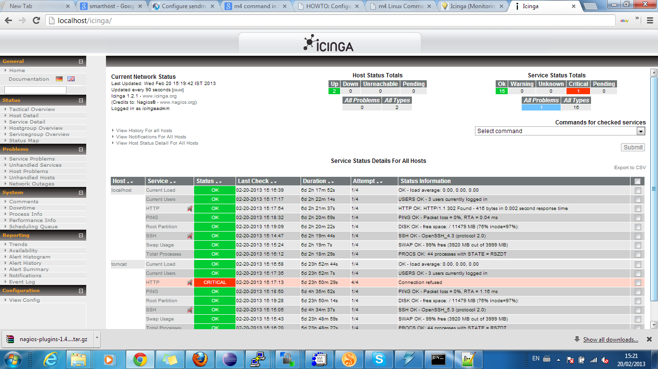

Final Note: Any number of processes can be added to be monitored by Icinga by modifying three files namely nrpe.cfg in remote machines and tomcat.cfg , commands.cfg in Icinga Server by adding or modifying appropriate commands like shown here for Servicemix and Tomcat monitoring in this document.

